**AWS VM Installation and Adding Volume**

**STEP 1** : Serach EC2 (Virtual Servers in the Cloud )

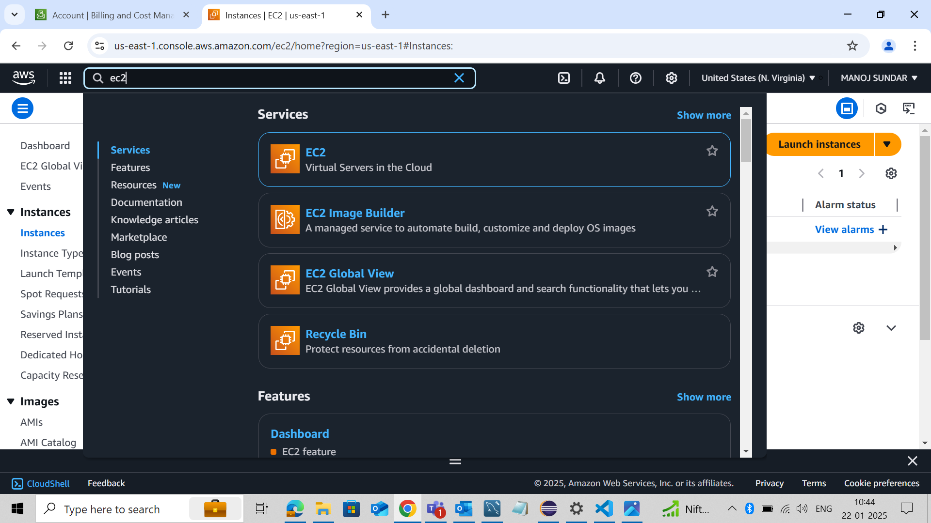**STEP 2 :** Choose Instances from menu and Click Launch Instances

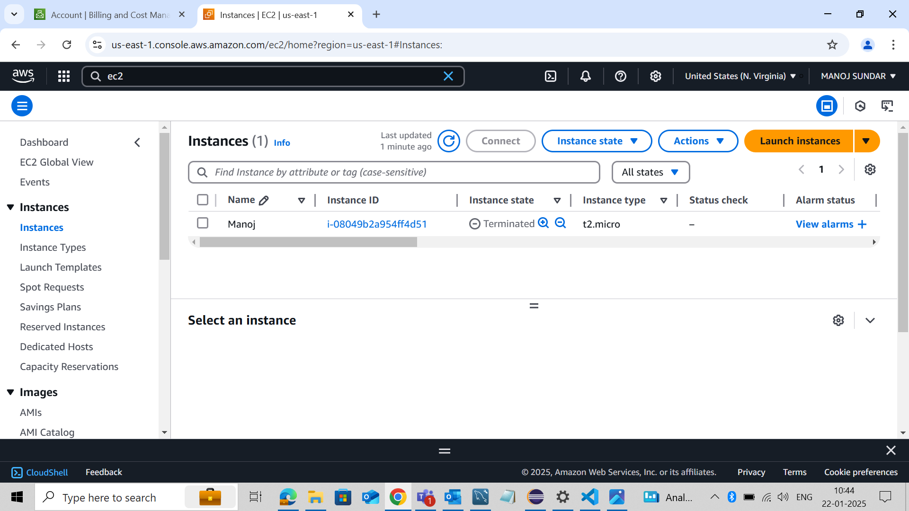

**STEP 3 :** Add Name

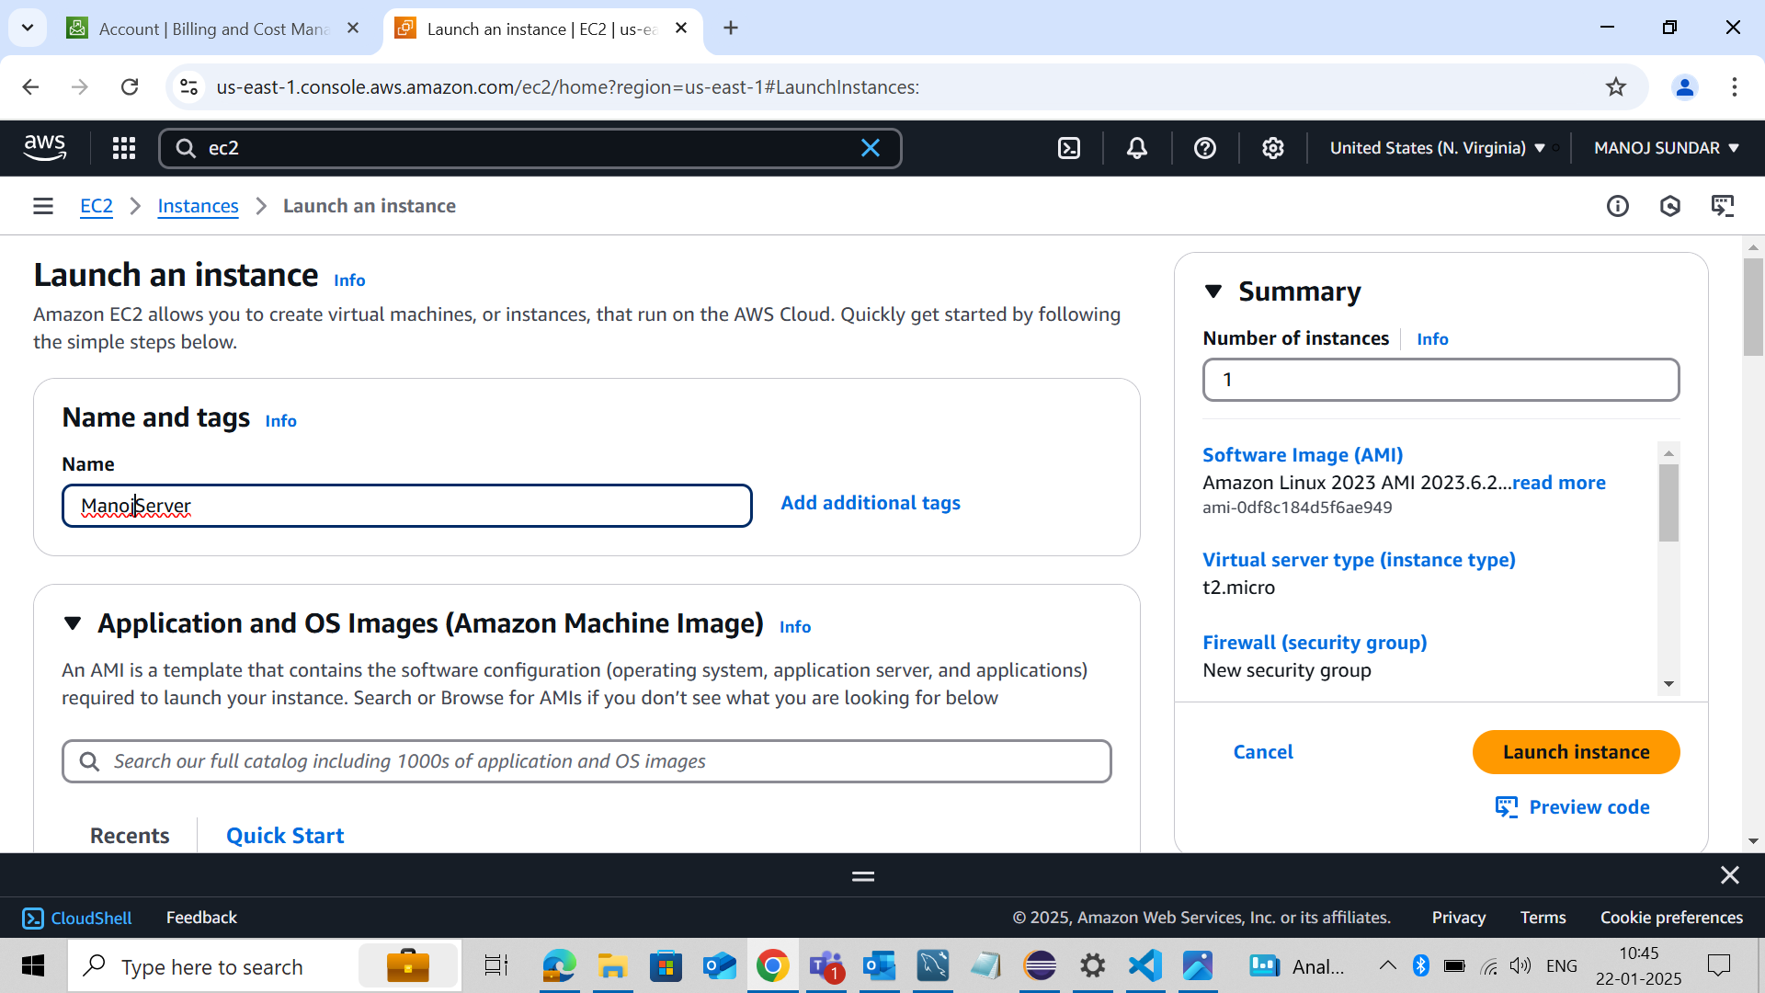

**STEP 4 :** Select OS (Operating System) as Debian

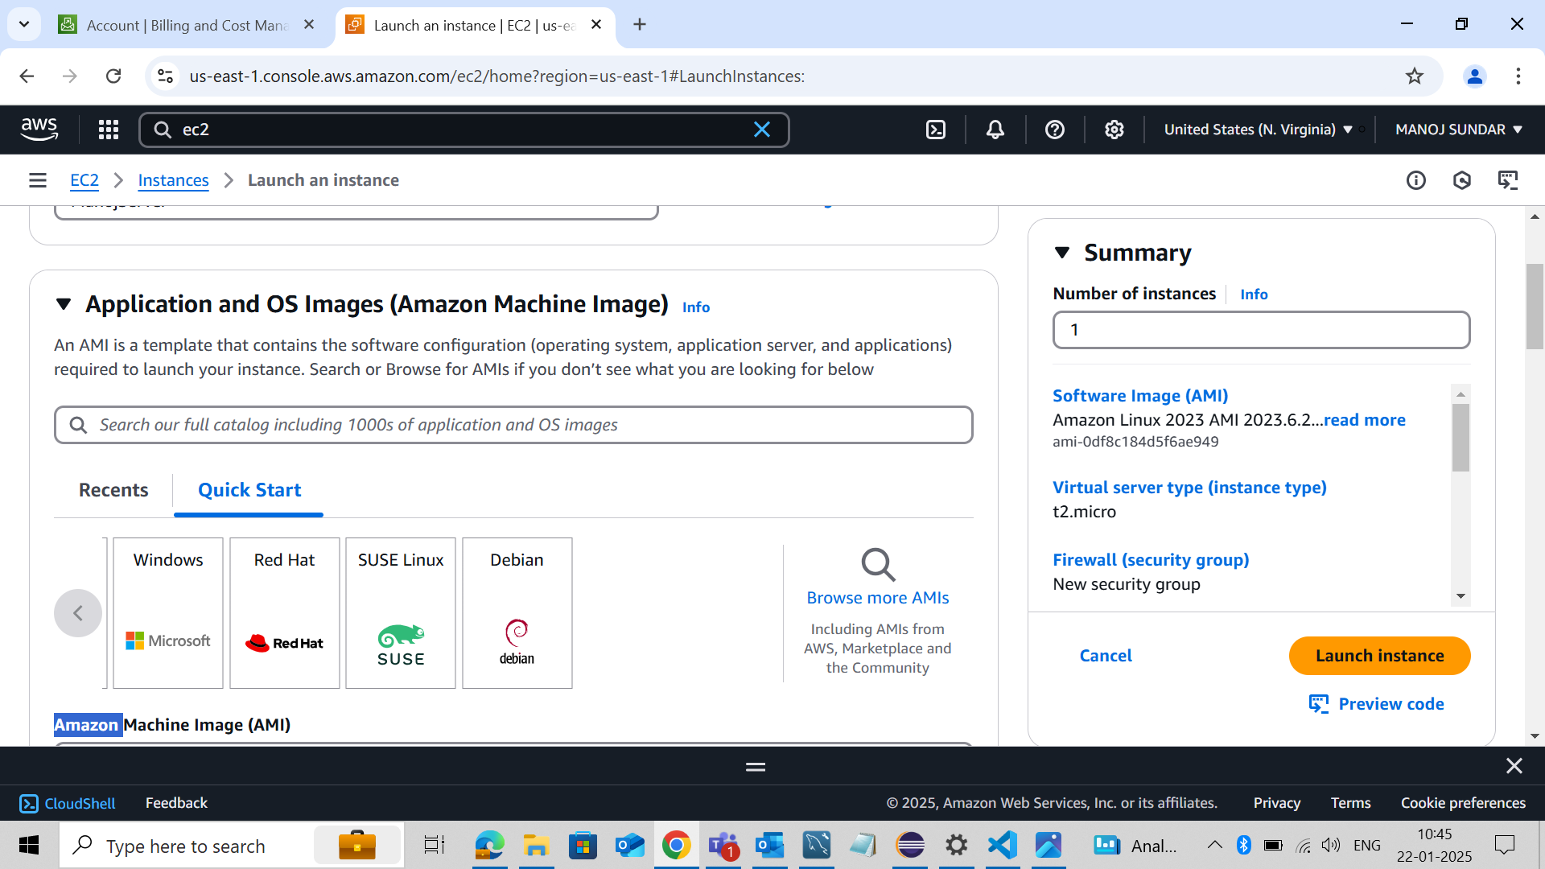

**STEP 5 :** Key Pair will be Default Value

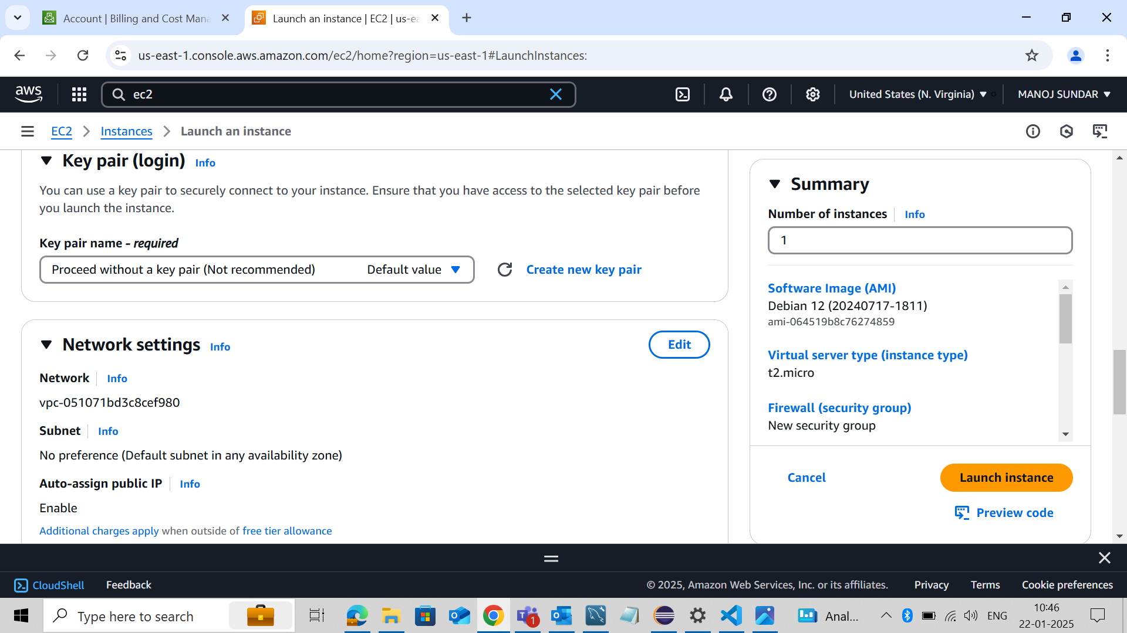

**STEP 6 :** Firwall and To Allow SSH and Use My IP

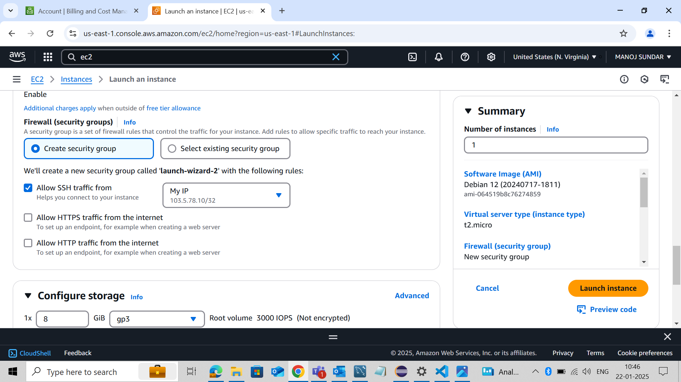

**STEP 7 :** Select Configure Storage

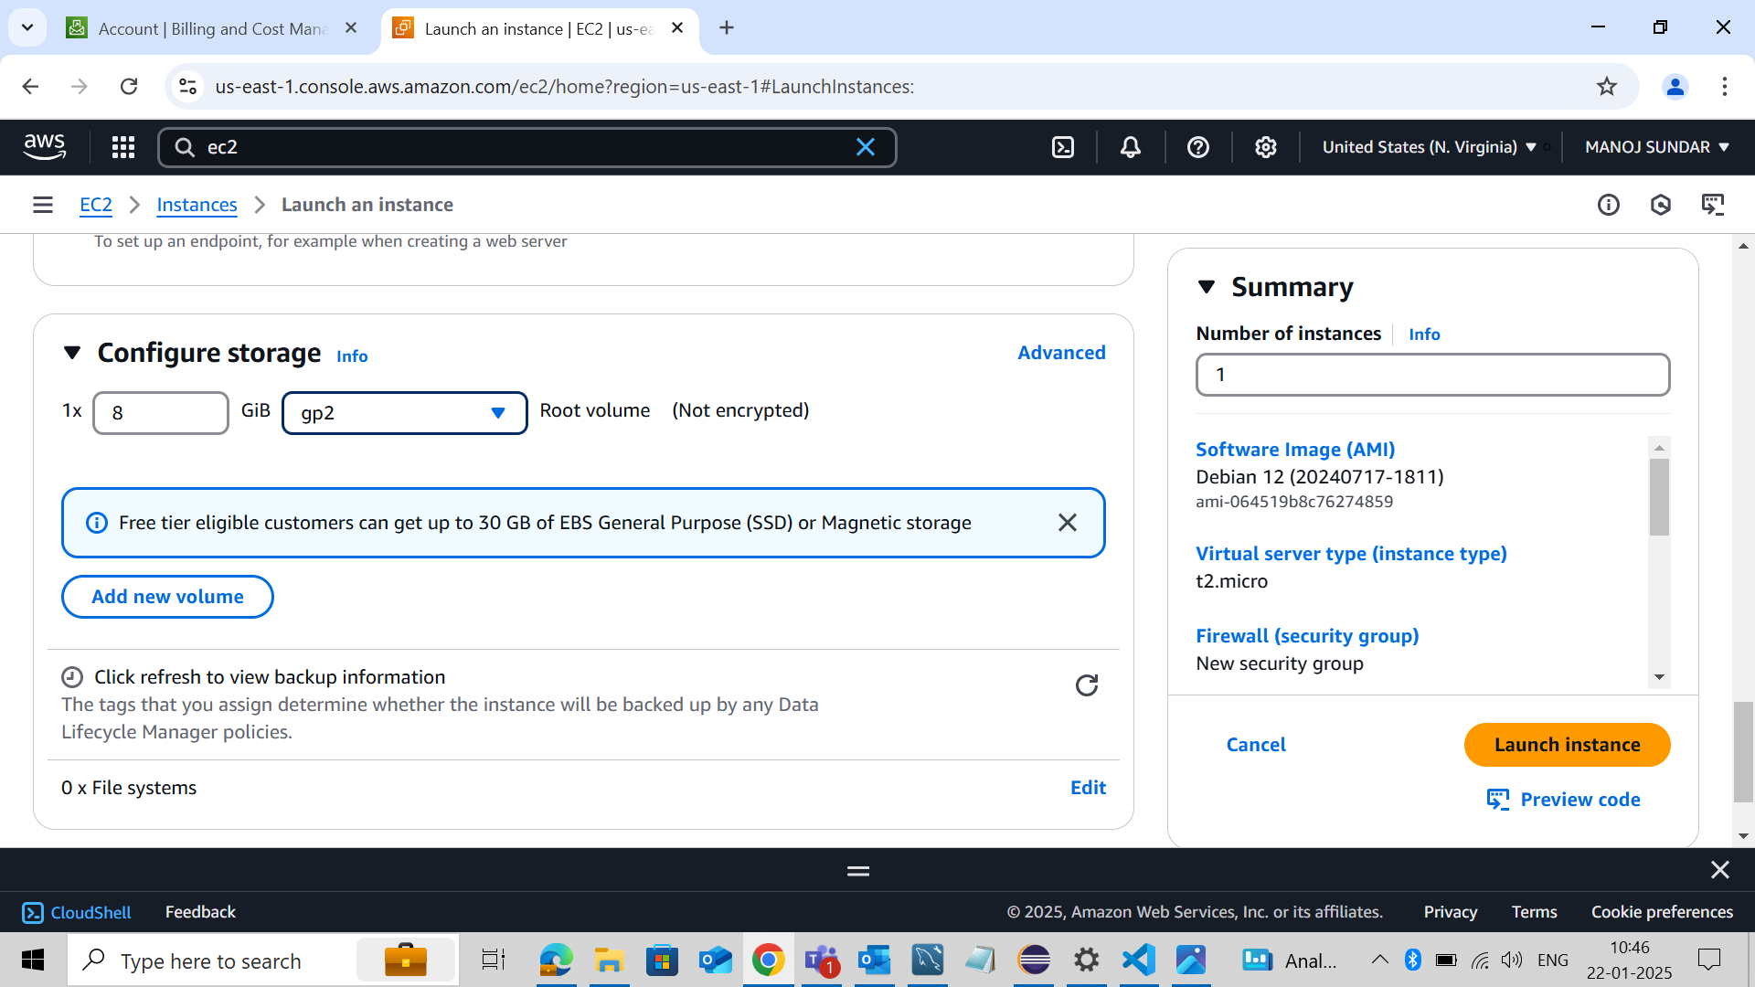

**STEP 8 :** Instances Has launched Successfully

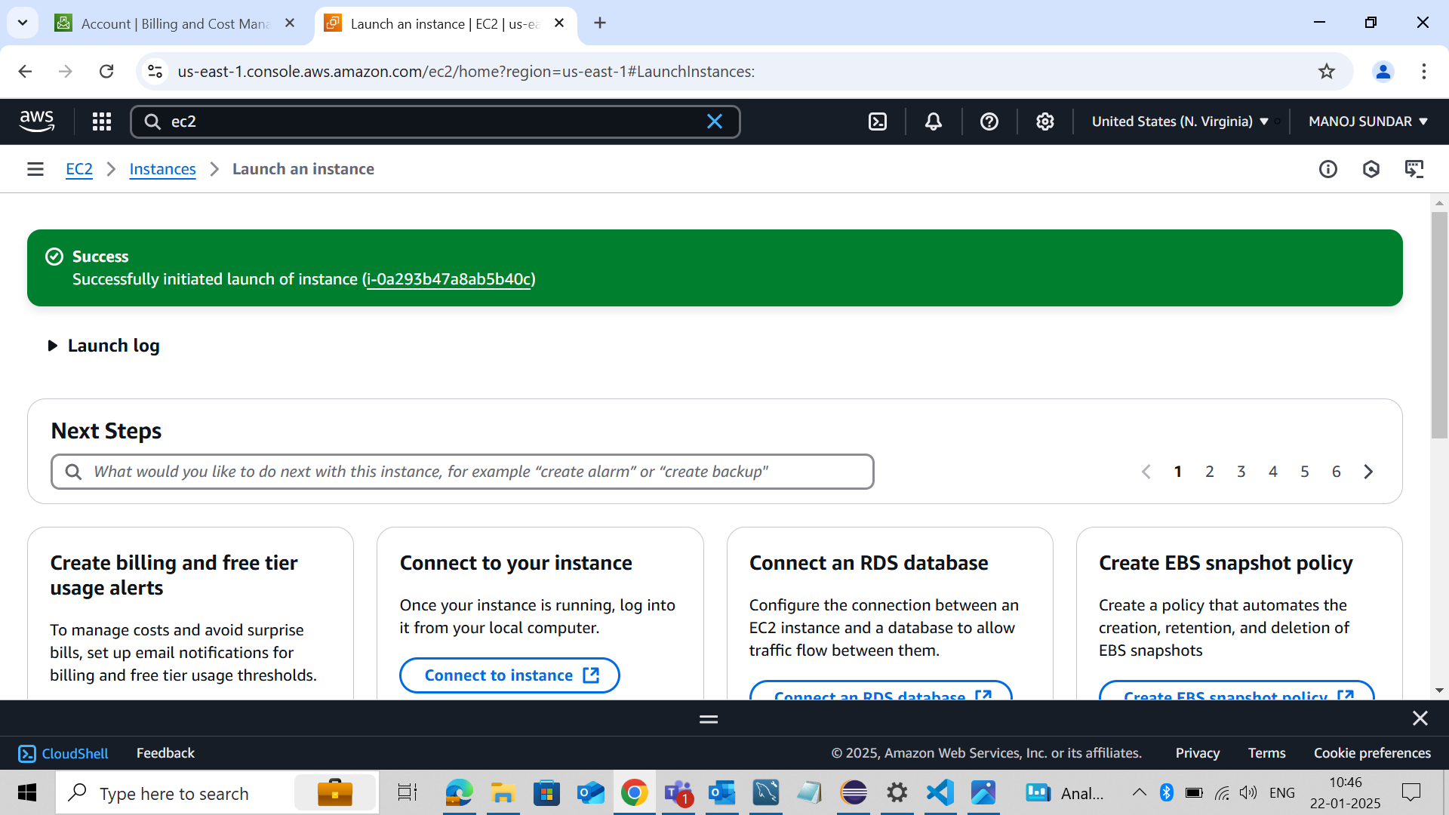

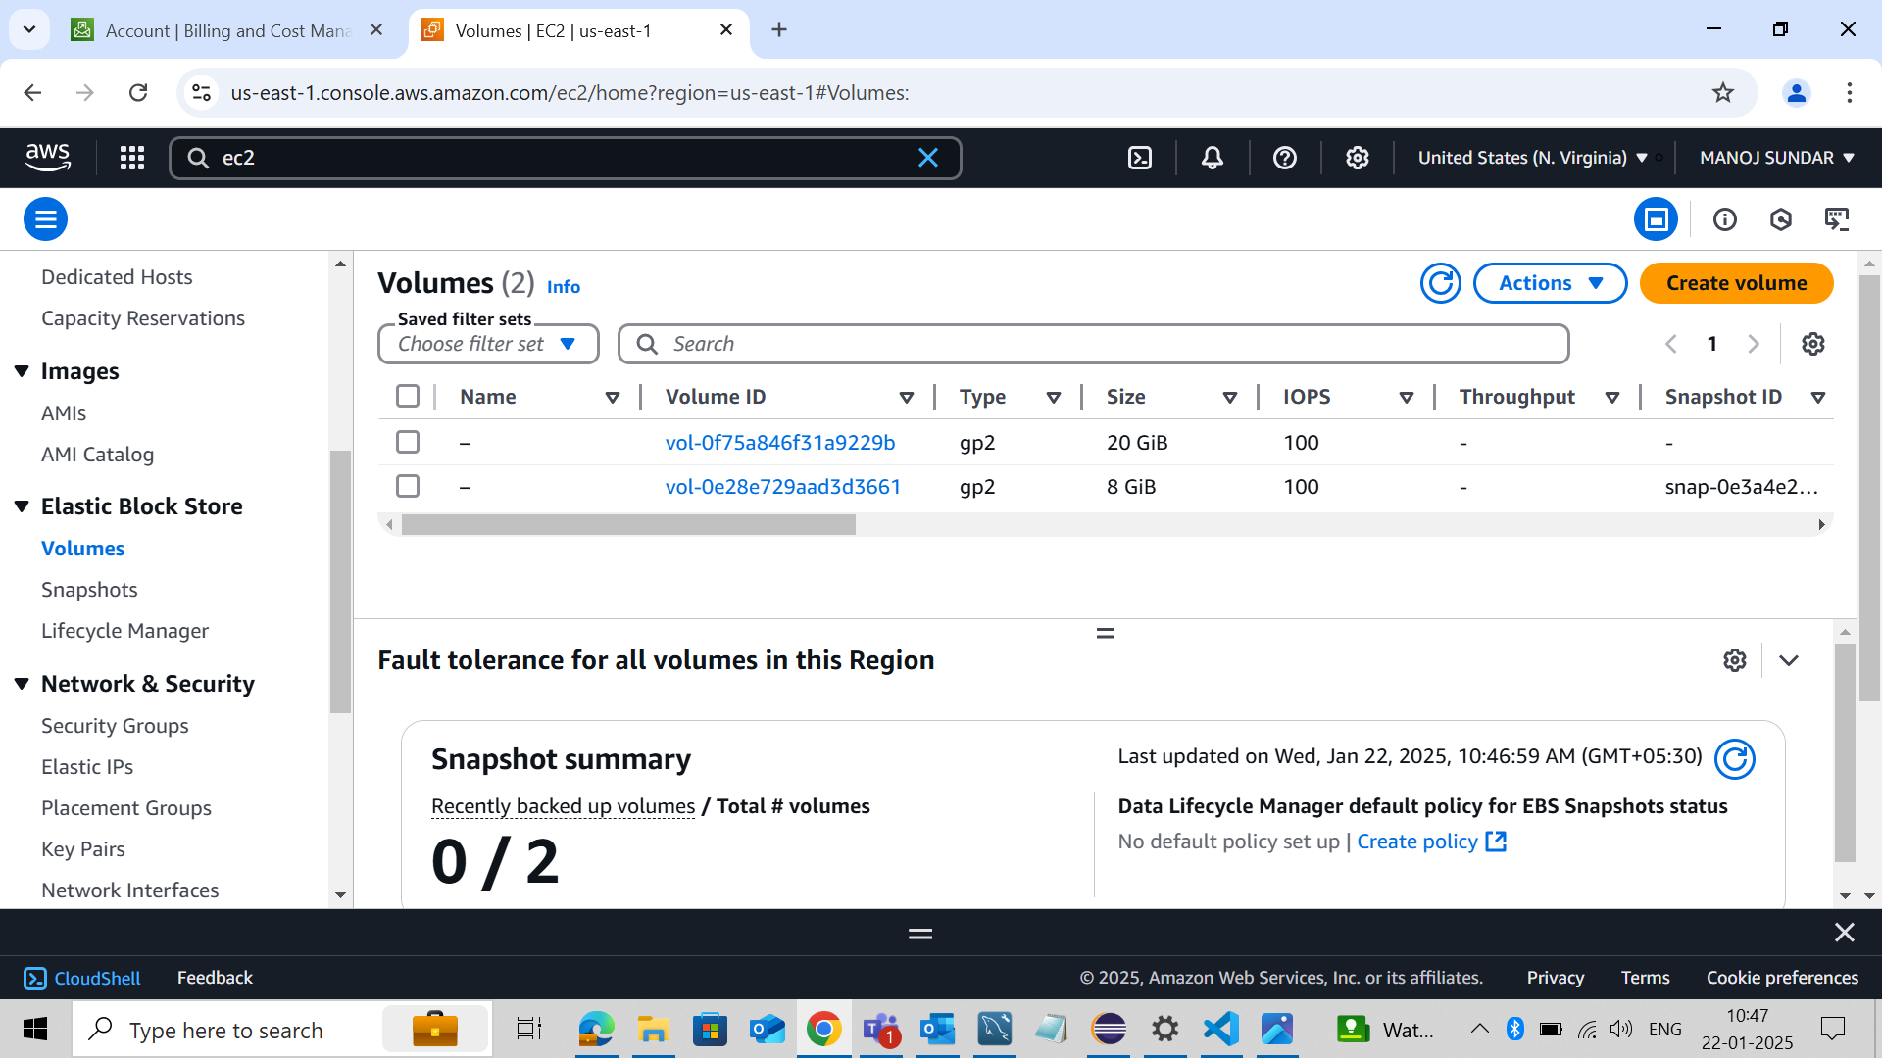

**STEP 9 :** Create Volume

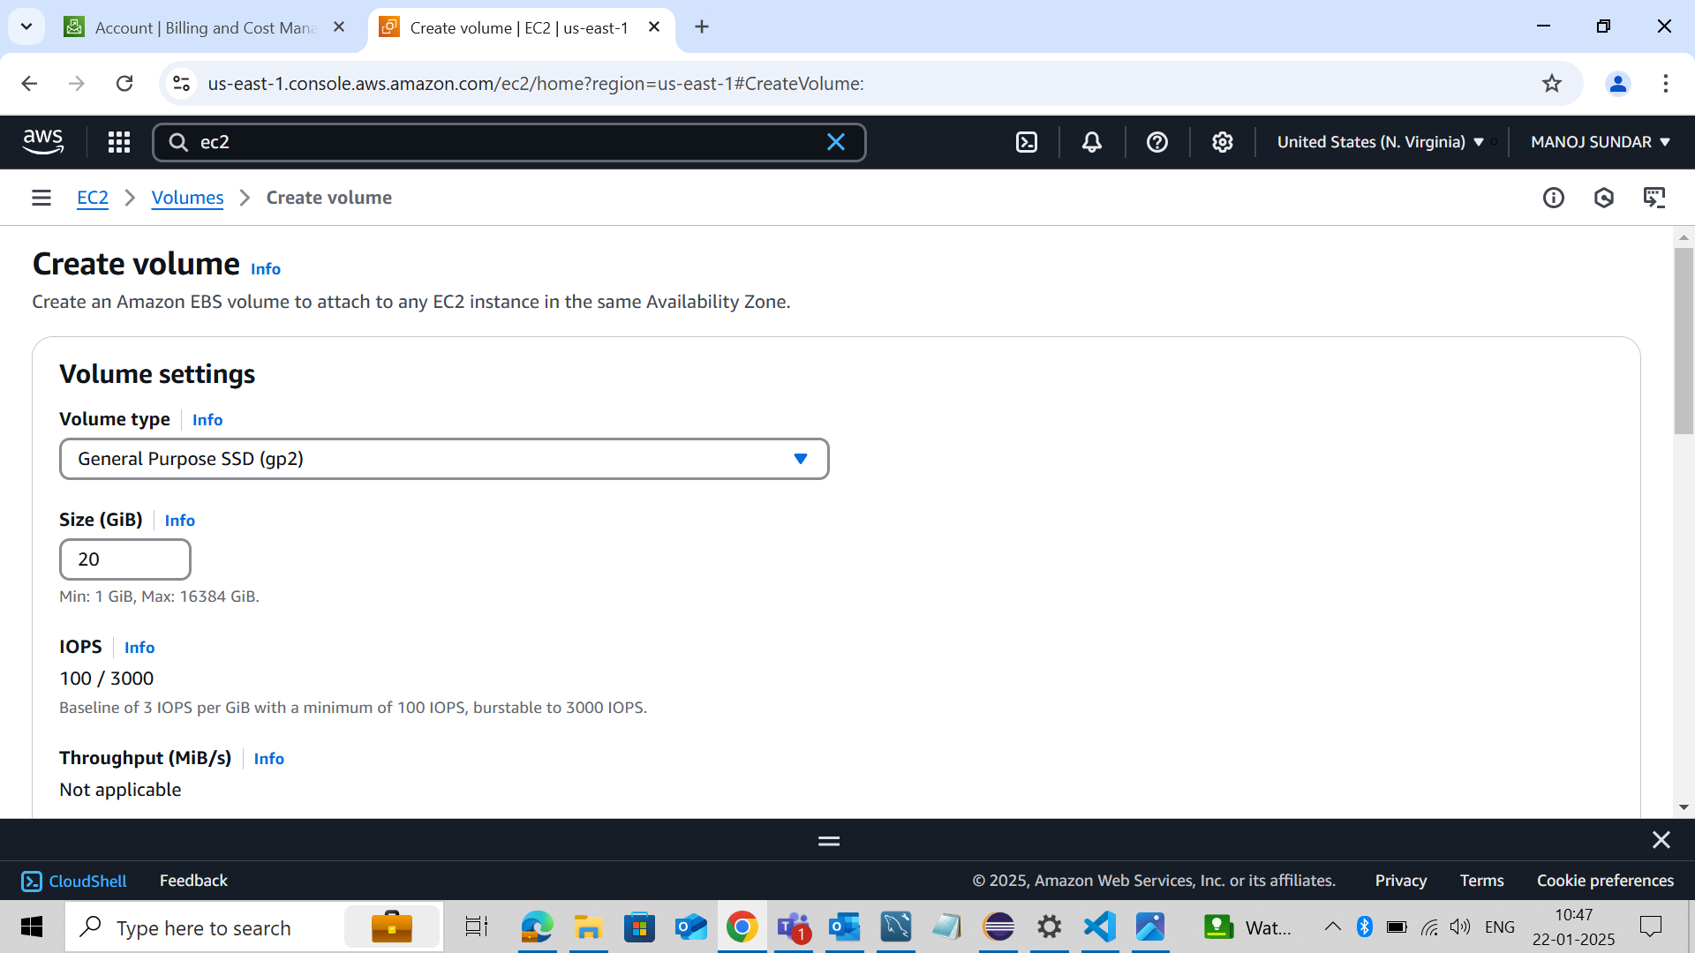

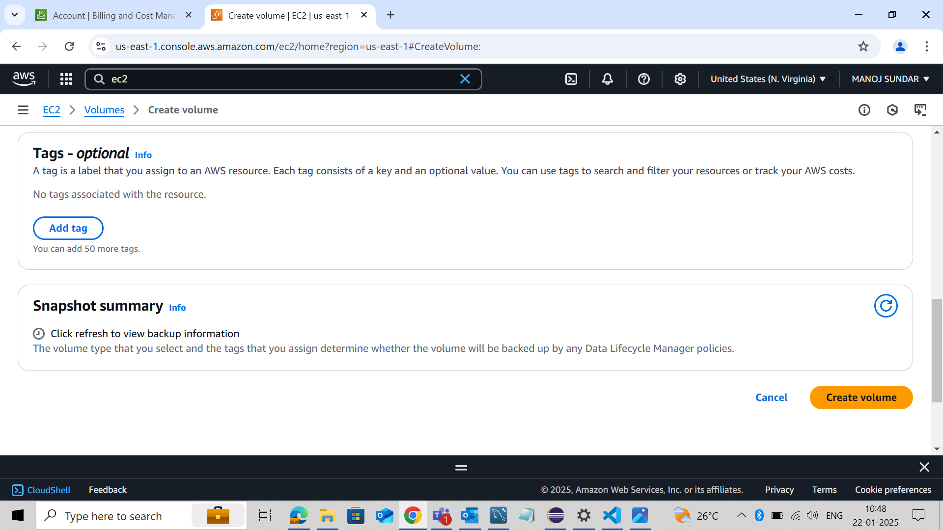

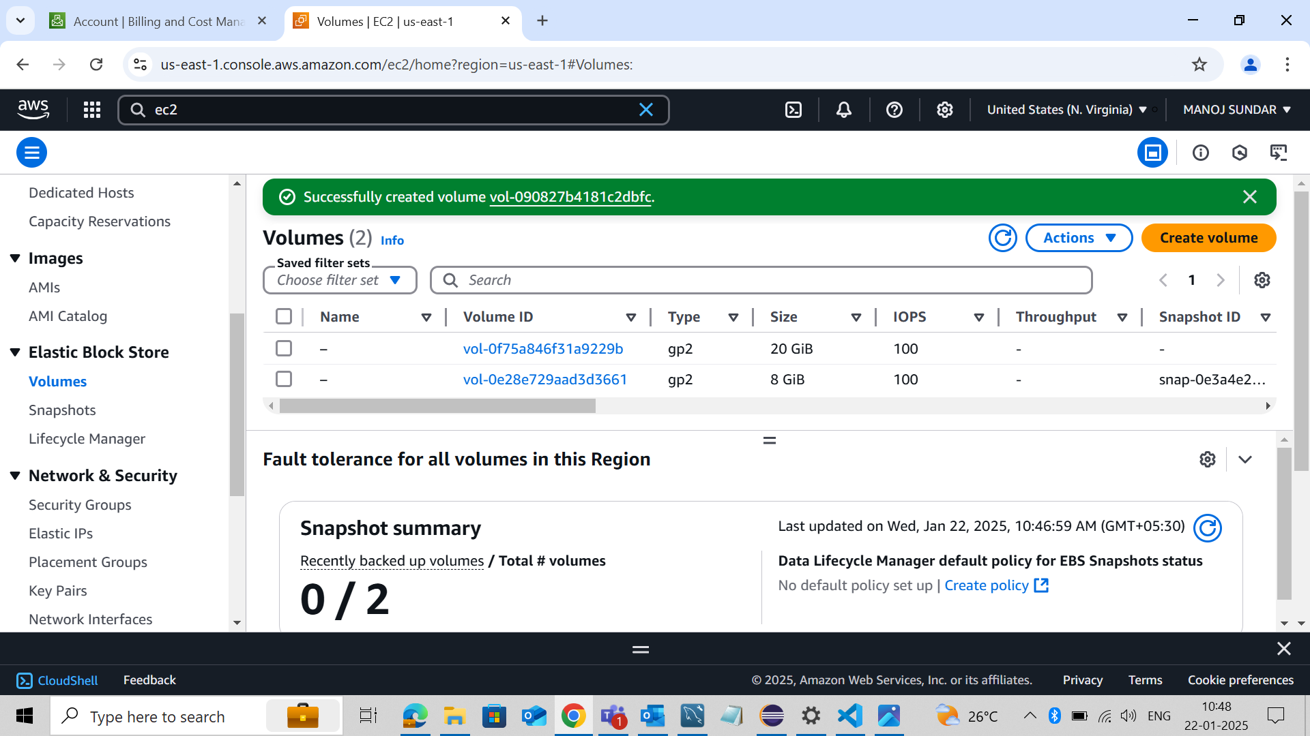

**STEP 10 :** Successfully Attached Volume

